Actualización BIOS (v1.45).
- Ejecutamos fichero r15uj24w.exe. Aceptamos las condiciones.
- Seleccionamos solo extraer ficheros:
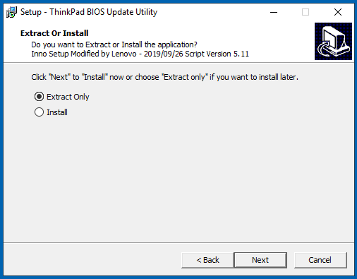
- Colocamos el fichero logo.jpg en el directorio. Si no lo ha generado el instalador, se ha de hacer a mano:
C:\DRIVERS\FLASH\ r15uj24w \...\Rfs\StartupImages
- Ejecutamos el fichero WINUPTP.exe. El sistema realizará la actualización de la BIOS.
(ruta C:\DRIVERS\FLASH\ r15uj24w \...).
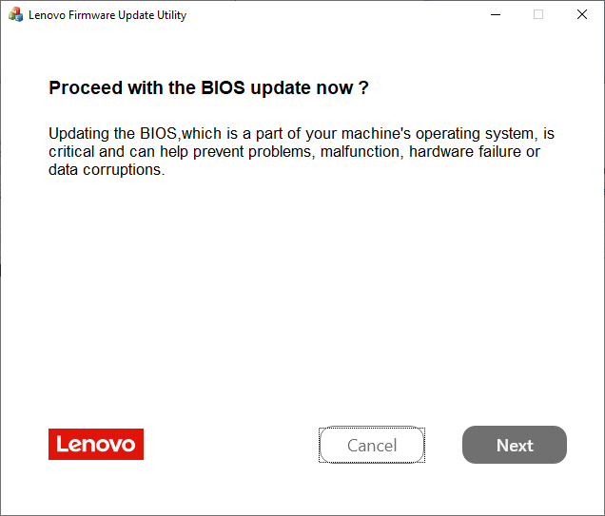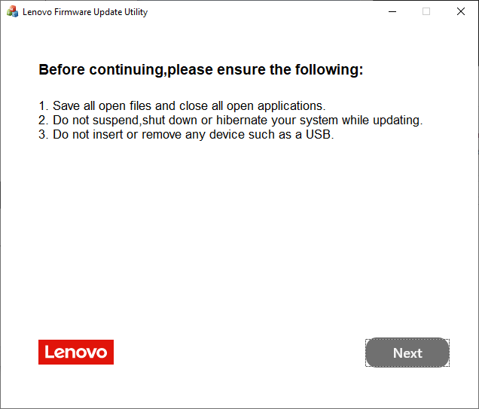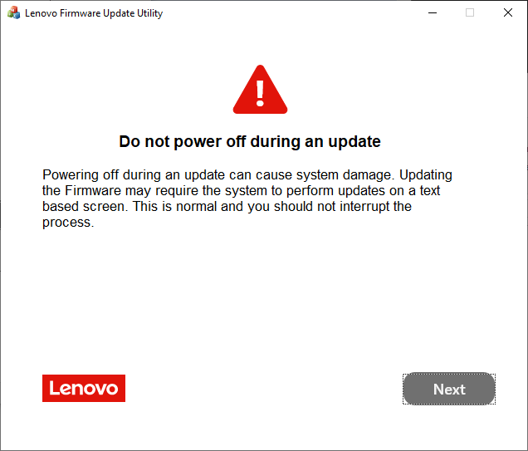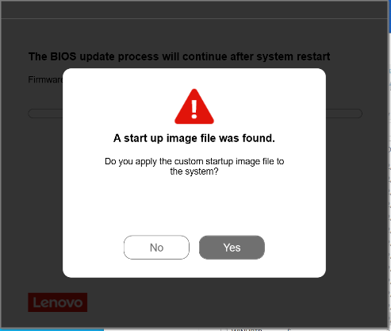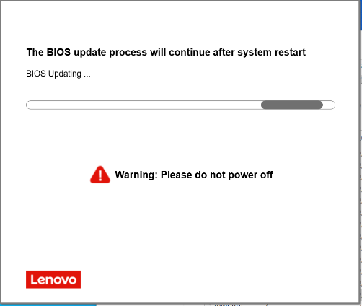

Package | BIOS | (BIOS ID) | ECP | (ECP ID) | Rev. | Issue Date
R15UJ24W | 1.45 | (R15ET64W) | 1.13 | (R15HT33W) | 01 | 2026/04/24

Una vez finalizado, el sistema se reinicia. Dejamos que finalicen los trabajos de actualización.
Una vez dentro de Windows, eliminamos la carpeta generada (C:\Drivers\....\ ).

Carga de valores.
- Ejecutamos fichero ThinkBiosConfig.
- Seleccionamos el fichero *.ini del producto que queremos configurar y pulsamos en ejecutar.
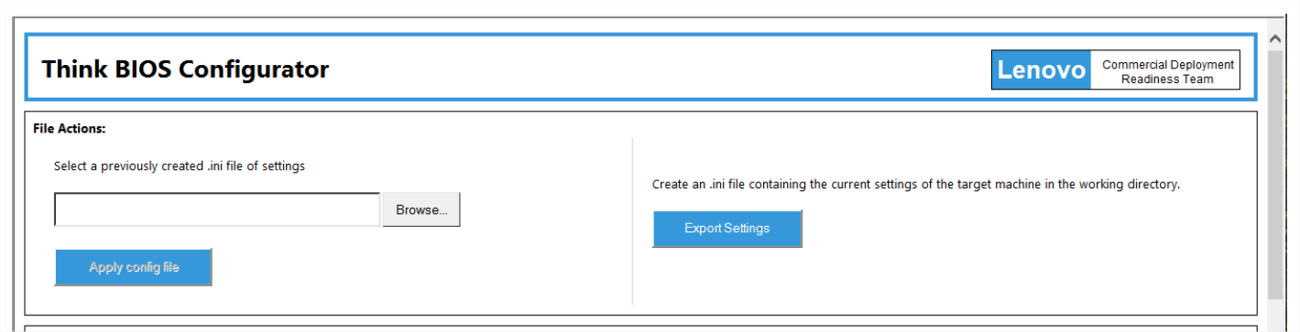
- El sistema nos dirá que tras el reinicio se aplicarán los cambios.

Summary of Changes:
<R15UJ24W>
UEFI: 1.45 / ECP: 1.13
[Important] Enhancement to address security vulnerability, CVE-2025-2295, CVE-2025-3052, CVE-2025-10238, CVE-2025-10237.
(New) Added new RootCA for Lenovo Cloud.
(New) Updated Secureboot DBX to v1.5.0.

<R15UJ23W>
UEFI: 1.44 / ECP: 1.12
[Important] Enhancement to address security vulnerability, LEN-167098, CVE-2025-20064, CVE-2025-20068, CVE-2025-20105, CVE-2025-20028, CVE-2025-20027, CVE-2025-20005, CVE-2025-22444,
CVE-2025-22850, CVE-2025-20073, CVE-2024-7344, CVE-2024-39356, CVE-2024-39271,
CVE-2024-38805, CVE-2024-38796, CVE-2024-45332, CVE-2024-12533.

<R15UJ22W>
UEFI: 1.43 / ECP: 1.12
[Important] Enhancement to address security vulnerability, CVE-2023-45236, CVE-2023-45237, LEN-141561，LEN-174328.
[Important] Fixed an issue where BIOS Update Utility will be blocked by Microsoft "Vulnerable Driver Blocklist”.
(Fix) Fixed the Lenovo Cloud Boot Option disappears.

<R15UJ21W>
UEFI: 1.42 / ECP: 1.12
[Important] Enhancement to address security vulnerability,CVE-2024-24853,CVE-2023-41833,CVE-2023-23904,CVE-2023-22351,CVE-2023-25546,CVE-2024-29979,CVE-2024-29980,LEN-154756,LEN-148267

<R15UJ20W>
UEFI: 1.41 / ECP: 1.12
(New) Added MT for S2 gen5 and S2 Yoga gen5.

<R15UJ20W>
UEFI: 1.41 / ECP: 1.12
[Important] Enhancement to address security vulnerability, CVE-2023-27504, CVE-2023-28402, CVE-2023-45229, CVE-2023-45230, CVE-2023-45231, CVE-2023-45232, CVE-2023-45233, CVE-2023-45234, CVE-2023-45235,CVE-2023-45236, CVE-2023-45237, CVE-2022-21894, CVE-2023-24932,
(New) Updated Version 04.33.000 code of FIT's InROM diagnostics.
(New) Updated Microsoft Corporation KEK2K CA 2023.

<R15UJ19W>
UEFI: 1.40 / ECP: 1.12
[Important] Enhancement to address security vulnerability, CVE-2022-40982.CVE-2022-0778
CVE-2022-4304, CVE-2022-40982, CVE-2022-37343, CVE-2022-44611, CVE-2022-27879,
CVE-2022-38083, CVE-2022-43505,CVE-2023-5058.

<R15UJ18W>
UEFI: 1.37 / ECP: 1.12
[Important] Enhancement to address security vulnerability, CVE-2022-21198.
(New) Update version 04.27.000 code of FIT's InROM diagnostics.

<R15UJ17W>
UEFI: 1.36 / ECP: 1.12
[Important] Enhancement to address security vulnerability, CVE-2022-21198.
(New) Update version 04.26.000 code of FIT's InROM diagnostics.
(New) Update Wi-Fi drivers.

<R15UJ16W>
UEFI: 1.35 / ECP: 1.12
[Important] Enhancement to address security vulnerability, CVE-2022-21151, CVE-2022-0005, CVE-2021-33122,CVE-2021-33123, CVE-2021-33124, CVE-2021-33103
(New) Update version 04.25.000 code of FIT's InROM diagnostics.
(New) Update Comet Lake MCU.

<R15UJ15W>
UEFI: 1.33 / ECP: 1.12
(New) Update GOP GOP_9.0.1092_2_VBIOS_1022_2.

<R15UJ14W>
UEFI: 1.32 / ECP: 1.12
[Important] Fixed some security issues.
(New) Updated Version 04.18.000 code of FIT's InROM diagnostics.
(New) Updated Comet Lake-U42 MCU(PV) to m94806ec_000000ec, Comet Lake-U62 MCU(PV) to m80a0660_000000ea.
(New) Update E-label v3.03.1.08.
(New) Update COPYRIGHT YEAR to 2021.
(Fix) Fixed an issue that cursor displayed on initial screen.

<R15UJ13W>
UEFI: 1.31 / ECP: 1.12
(New) Add Fn + Tab function zooming feature.
(Fix) Fixed battery capacity error in Lenovo diagnostic.
(Fix) Fixed an issue that Speaker can't be kept mute state after resume from Shutdown in DC mode.
(Fix) Fixed an issue that FnLock OSD can't be shown when change "keyboard top-row function" option in Commercial Vantage.

<R15UJ12W>
UEFI: 1.30 / ECP: 1.11
(New) Support DYTC 5.0 for ITS driver 2.0.xxx

<R15UJ11W>
UEFI: 1.29 / ECP: 1.11
(Fix) Fixed the cursor issue in top left corner when POST.
(New) Support new Samsung memory.
(New) Updated new Thermal Table.

<R15UJ10W>
UEFI: 1.28 / ECP: 1.10
(New) Update Thermal table.
(New) Update the Synaptics Prometheus driver to 6.0.47.1105.
(New) Updated Enhanced deployment boot mode to skip Freeze lock/Block SID commands.
(New) Added modification to enable pTRR for DDR4 system.
(Fix) Fixed the issue that POP can't be cleared for Power-On Password Control.
(New) BIOS rollback is disabled as security issue.

<R15UJ09W>
UEFI: 1.26 / ECP: 1.09
(New) Support Country code in SMBIOS Type 11.
(New) Updated Comet Lake-U42 MCU to M94806EC_000000DE, Comet Lake-U62 MCU to M80A0660_000000E0.
(New) Updated CML UNDI Driver to RtkUsbUndiDxe.2.030.2020.08.13.efi.
(New) Updated Version 04.15.000 code of FIT's InROM diagnostics
(Fix) Fixed WUFU update stopping at password prompt.

<R15UJ08W>
UEFI: 1.25 / ECP: 1.09
(New) Support TCO logo at POST.
(New) Add WUFU support for Nuvoton TPM.
(New) Drop TXT disabling feature for DeviceGuard.
(Fix) Fix POST hang issue when Lindy USB-C cable is attached.

<R15UJ07W>
UEFI: 1.23 / ECP: 1.09
(Fix) Fixed abnormal shutdown when unplug the adapter.
(New) Update thermal table.
(Fix) Hynix memory size show incorrect.
(New) Support HTTPs Boot v1.0.

<R15UJ06W>
UEFI: 1.16 / ECP: 1.07
(New) Added support for the following products:
ThinkPad L13 Gen 1 (Machine Types:20R3, 20R4)
ThinkPad L13 Yoga Gen 1 (Machine Types:20R5, 20R6)
(New) Disable ISH function on Clamshell.
(Fix) Fixed incorrect Lenovo Copyright information on Diagnostics screen.
(Fix) Fixed WU fail On combined BIOS.

<R15UJ05W>
UEFI: 1.11 / ECP: 1.06
(New) Change charge led behavior.
(Fix) Update E-Label v3.02.1.05.
(New) Update thermal table.
(Fix) Update SA/IA/GT VR setting of CPU6+2.

<R15UJ04W>
UEFI: 1.06 / ECP: 1.03
(New) Update thermal table.
(Fix) System randomly BSOD caused by Samsung memory training problem.

<R15UJ03W>
UEFI: 1.03 / ECP: 1.03
(New) Disable SAGV option.
(New) Disable C6Dram by Intel request.

<R15UJ02W>
UEFI: 1.03 / ECP: 1.03
(New) Update eLable_v3.01.1.03
(Fix) Fix IR camera flicker issue.
(Fix) Fix DPTF mode switch function.
(Fix) Fix led blink issue when EC power on.
(New) Update thermal setting delay time.

<R15UJ01W>
UEFI: 1.01 / ECP: 1.00
Initial Release

